Phase 2 Martin Home Lab
Install and Configure pfSense on GMKtec 1
Enterprise Network Project
May 21, 2026

Install and Configure pfSense on GMKtec 1

After the physical components were complete, setting up a strong firewall is an essential next step for the lab. Initially I tried to install pfSense bare-metal hypervisor however problems arose. In this phase I installed Proxmox as a bare-metal hypervisor. Proxmox is a VM manager that was configured. Using Proxmox, I installed the image of pfSense into the virtual machine. Finally, after these steps then I successfully configured pfSense onto the GMKtec device.
Initial Attempt Set up:
Using BalenaEtcher, I etched an instance of Netgate installer disk image file. This was my initial attempt to installing the bare-metal pfSense hypervisor onto the GMKtec router. All of the steps regarding the installation and configuration process went smoothly accept when verifying layer 3 connectivity. After running through the configuration steps (that I will address in detail later), I attempted to connect to the LAN using a laptop that was connected to the Control Switch via cat6a. In the command line of the laptop, I noticed that the laptop did not receive an IP address within the DHCP range of the gateway DHCP router (192.168.10.100-192.168.10.200). In fact, the laptop’s IP address was 169.x.x.x which signaled to me that it was given from APIPA.
Additionally, when I attempted to ping the pfSense firewall (192.168.10.1), the laptop received 100% loss. This signaled to me that there was no layer 3 connectivity between the switch and the LAN. Furthermore, after doing more research, I noticed that the virtual network interface (vtnet1), could not be discovered by the pfSense configuration. I learned that it is common for pfSense installers to not recognize Realtek NIC and instead favor Intel NICs more. After realizing this was the culprit, I switched my approach and instead installed Proxmox VM as a level 1 hypervisor on my device. From Proxmox, I then installed pfSense image using netgateinstaller.iso file.

Proxmox Installation
After Flashing Proxmox image onto my USB drive, I successfully installed Proxmox on to the GMKtec firewall. Next, I created the appropriate administrative username and password onto the firewall to establish connectivity. Next from the administrative laptop, I connected to the Proxmox host remotely using port host IP address and port 8006. From this port I was able to create a virtual machine using the pfSense .iso file.
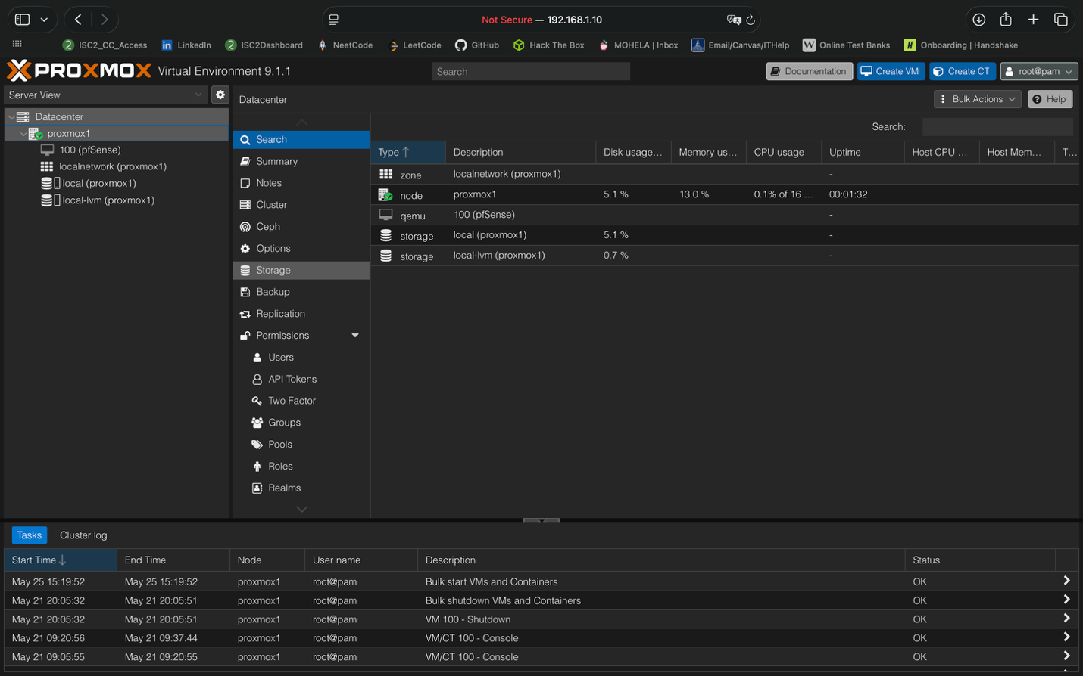

pfSense Image Download
Side problem: During this step of the process I ran into an additional problem that I am proud to have troubleshoot. When I downloaded the USB .img (which is different from the original disk image) of pfSense, I noticed that it came in a compressed .gzip file. This was not new to me, as I am familiar with decompressing files. However, the default MacOS app for decompression, utility.app, was not able to decompress the file and threw an error message “Erro 94 – Bad Message”. I solved this by decompressing the file using the gunzip command on the bash shell:
gunzip netgate-installer-amd64.img.gz

After running this code on the command line, I was able to unzip the compressed file and upload the pfSense image into the Proxmox VE installer as to create a new VM. This image was used as the boot device in Proxmox VE.

pfSense VM Set up –
Setting up the pfSense VM involved 5 steps. All steps of configuration are shown in the Summary (Options), and Hardware windows of the VM. In this section I will go over each of the steps and the configuration details of each step.
- Configure the Operating System and Machine – I configured the OS Type to “Other”. This was because pfSense does not run on windows or Linux OS, it uses FreeBSD (Unix system) so “Other” will suffice. Additionally, I added 2 cores as host and 1 socket. This is done because 2 cores assist in analyzing networking traffic for the pfSense router. The machine used for this Virtual machine was the default(i440fx). I440fx does a good job of emulating a stable version of the intel chipset. This works very well with pfSense.
- Configure BIOs and Memory – I allocated 2048 MiB for memory for the firewall. This gives the filesystems and process enough spaced for functionality. Next, I used the default (SeaBIOS) system. SeaBIOS is an older BIOS system that works well with pfSense so there was no need to change.
- Download ISO and Configure CD Drive – The CD Drive is the most critical piece of this virtual machine. This is because the drive decides which image will be booted up. The CD Drive was the pfSense image “iso/netgate-installer-v1.2-RELEASE-amd64.iso”. SCSI (Small computer system interface) was configured to VirtIO SCSI Single. VirtIO SCSI Single is a powerful controller type offered by Proxmox VE, that assigns a virtual controller to an individual disk. This allows Proxmox VE to offload disk-specific I/O processing to dedicated CPU threads. IDE and SATA would emulate slower/older hardware and are inefficient.
  - After doing more research I found that disk operations using VirtIO SCSI single are handled outside of the VM’s main event loop. This drastically reduce contention and latency, which results in a significantly higher storage performance.
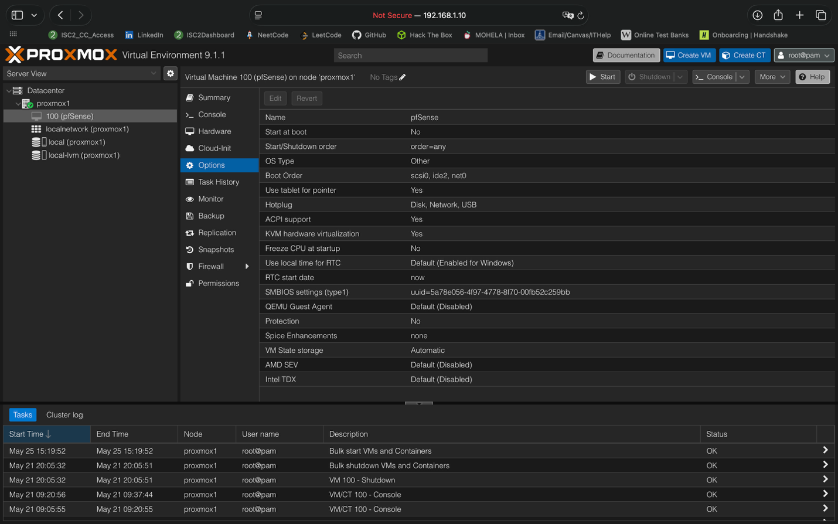
- ***IMPORTANT STEP*** Create 2 Virtual Bridges and 2 Network Devices – 2 virtual bridges were configured on Proxmox vmbr0, and vmbr1. Virtual bridges act as virtual switches that within the Proxmox VE hypervisor that connects data from the physical GMKtec NIC to the virtual network device (virtual NIC). This is crucial because pfSense’s OS (FreeBSD) will use its own two virtual NICs (vtnet0, and vtnet1) and it is important that the virtual NICs from pfSense has their own virtual bridge. Furthermore, it is important that each bridge is connected to the correlating physical NIC.
  - I made another mistake regarding bridges. During the initial setup I only had one virtual bridge configured on Proxmox VE. This wasn’t ideal because the virtual NICs within pfSense configuration (vtnet1, vtnet0) could not receive traffic on the same bridge effectively. I created the second bridge so that the virtual NIC connecting to the LAN will be able to effectively send and receive traffic on an appropriate IP address.
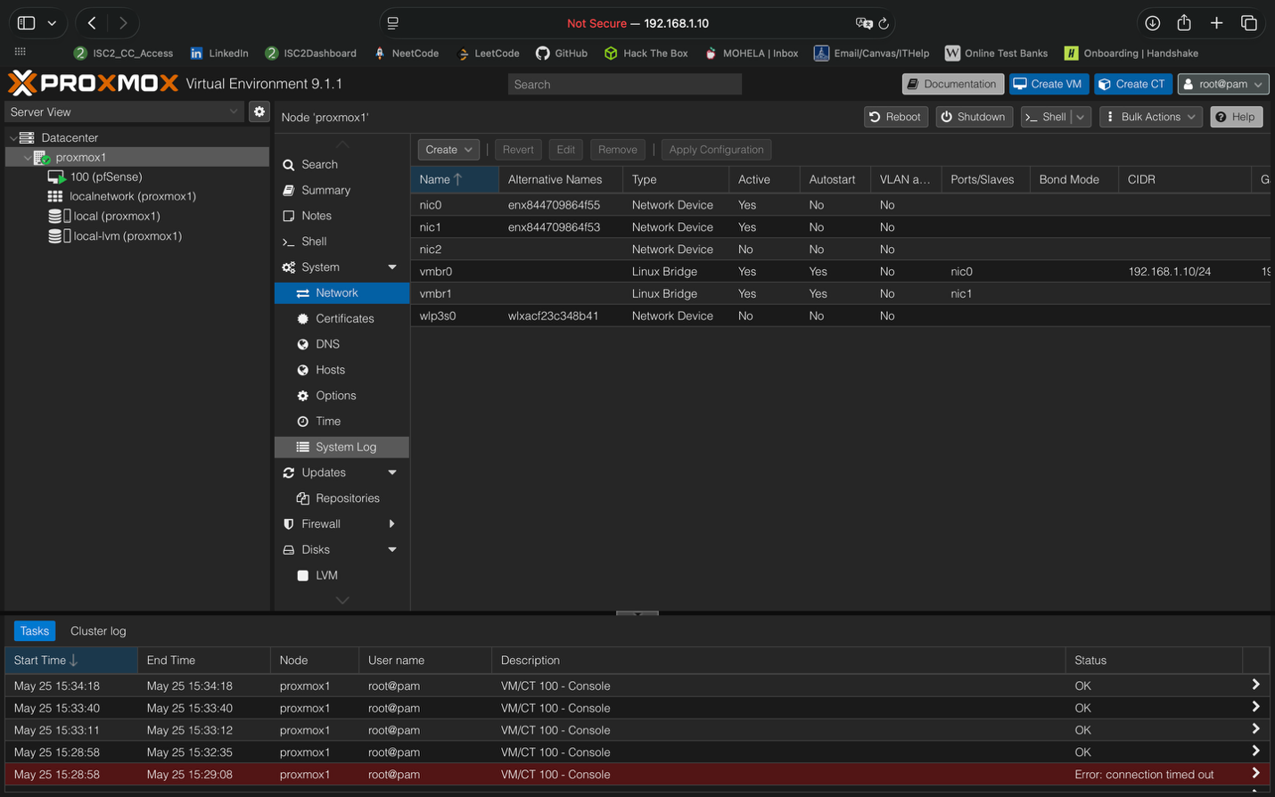
- Connect Bridges to NICs – This step was simple but crucial. After the virtual bridges were created, I connected the virtual NICs to each virtual bridge. Nic0 connects to vmbr0, using VirtIO model, and respectively nic1 connects to vmbr1. This step was crucial in allow the separation of traffic between the WAN and LAN in pfSense.

Configure WAN Interface – During the initial pfSense console setup, the WAN interface was assigned to the vtnet0 virtual network adapter, which is connected to vmbr0 and ultimately mapped to the physical interface connected to the ISP router. This completed the logical interface assignment required for later network configuration.

Pictures of Configuration